EX:1 8-queen problem

Program:

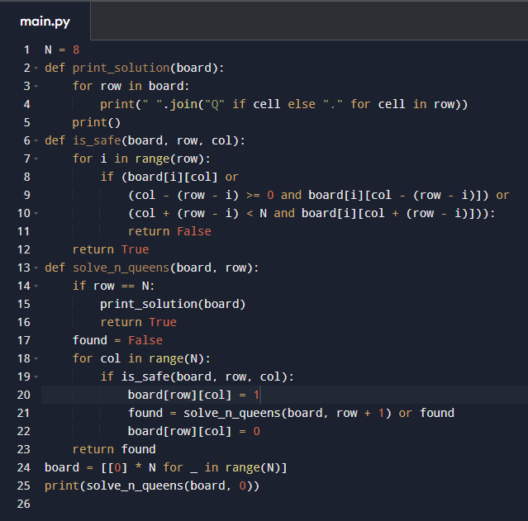
Output:

Output:

